Youngjun Kim

Block C

Computer Programming: ICT 11

May 10, 2017

**AI PROGRAM: SPEECH RECOGNITION**

Speech recognition is the ability of a machine or program to identify words and phrases in spoken language and convert them into machine-readable format. The program of speech recognition learns by deciphering what the user typed text and then converting them into machine-readable format to then speak the text. Some disciplines required to apply designs to this system are computer science, linguistics, and electrical engineering. The program was created in the early 1970’s HMM , the approach to speech & voice recognition was invented by Lenny Baum of Princeton University and shared with several ARPA contractors including IBM. Two examples of systems that incorporates speech recognition is Windows Speech Recognition, and IBM ViaVoice. 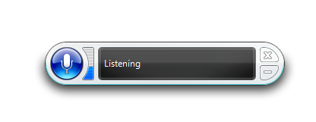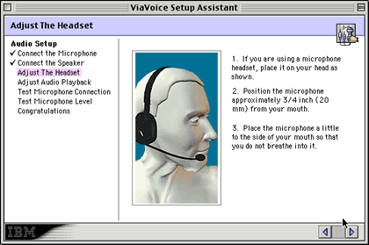

An intelligent principle that makes Windows Speech Recognition “intelligent” is the macro feature. It allows users to use custom macros which allows the use of commands that are based from the NLP. An intelligent principle that makes IBM ViaVoice “intelligent” is the process of being able to read many specific words and sentences in order to make the software adapt itself to the specific users sound and intonation features. I think the example of the speech recognition listed above (Windows Speech Recognition, IBM ViaVoice) has almost reached the goals the creator has set for it. It can decipher most of spoken language and turn it into correct readable text (80% of the time). I personally think modifications need to be done in the audio aspect to make this system work better. Most of the times we speak into our microphones but the microphones do not actually transmit what is actually said, therefore not giving correct spoken language for example to programs like the Apple Iphone AI system, Siri. One implication I have found through research is that the Speech Recognition System actually beat humans typing system. However, other than that I do not think there could be any bad results for humans through evolving this AI system unless they add this AI system to functional robots. The good part of the Speech Recognition System is that it shortens the time needed to type and instead could just speak and instantly decipher into text.

**Sources:**

<http://www.npr.org/sections/alltechconsidered/2016/08/24/491156218/voice-recognition-software-finally-beats-humans-at-typing-study-finds>

This is where I found one of the implications in the AI system.

<https://en.wikipedia.org/wiki/Speech_recognition>

This is where I found the basis of speech recognition. Why it was created, how, when, where.

<https://en.wikipedia.org/wiki/Windows_Speech_Recognition>

This is where I found one of the examples for the Speech Recognition system and how, why it was created and benefits.

<https://en.wikipedia.org/wiki/IBM_ViaVoice>

This is where I found the other example for Speech Recognition System and how, why it was created.